Functional Test Plan
For

CiviCRM Multi-value custom data import

Prepared by

Omayma ElTalawy
Revision History

Date | Version | Description | Author
August 1, 2016 | 1.0 |  | Omayma ElTalawy

CiviCRM Multi-value custom data import

Test Plan

Table of Contents

1. Introduction……………………………………………………………………………4
a. Document Purpose 4
b. Objectives 4
2 Project Scope ……………………………………………………………………..4
a. In Scope 4
b. Out of Scope 4
3 Project Resources………………………………………………………………...5
Project roles and responsibilities 5
4 Test Strategies/Techniques……………………………………………………..5
a. Test Design 5
b. Database 7
5 Project Tasks/Schedule…………………………………………………………..7
6 Defect Responsibility/Resolution………………………………………………...8
7 Exit Criteria………………………………………………………………………8
8 Goals and
Deliverables……………………………………………………………8

Introduction

This Test Plan provides the strategy for testing the project new feature “CiviCRM Multi-value custom data import”. This section of the Test Plan document describes the following.
- Purpose
- Objectives

Document Purpose
This Test Plan reviews:

- Existing project information,
- Business Requirements and critical transactions to be tested,
- Testing types and strategies to be implemented and
- A proposed testing schedule

Objectives
This document provides the platform for testing the project new feature “CiviCRM Multi-value custom data import”. The objective of testing is to see if the project meets the “Software Requirement Specifications”. This document will provide - (1) the guidelines for the testing team to test the functionalities embedded in the project and (2) help for evaluating the Software Quality of the new function added to the project.

Project Scope
This section of the Test Plan document describes the (1) Scope of the project “CiviCRM Multi-value custom data import”.

Scope of the Project
“CiviCRM” will be tested for its functionality against the newly added feature "CiviCRM Multi-value custom data import " to allow to the administrator to delete an investment and its entire related business object.

The testing includes testing for several functions like
- User Interface for the newly added feature " Multi-value custom data import"
- Custom field set for specific Contact Type.
- Successful import for all types of custom fields.

Project Resources
Table 1 describes the Roles, Responsibilities and Resource Name for the testing of the extension “CiviCRM Multi-value custom data import”.

Role | Responsibilities | Resource Name(s)
Testers | - Plan testing activities  - Execute Test Cases  - Find, report and track defects  - Measure test effort  - Analyze results
Developers | - Deliver jar file for the new feature to the application  - Provide Testers with feedback regarding changes, new functionality  - Provide expertise and knowledge of the application-under-test  - Eliminate agreed upon defects
Business Analysts | - Interview Users  - Create Business Requirements  - Create Test Scenarios, Test Cases
Users | - Describe and review Business Requirements  - Describe and review user profiles  - Perform Customer Acceptance Testing (CAT)
Desktop Administrators | - Installation of extension  - Troubleshooting of software
Table 1 - Project Roles and Responsibilities

Test Strategies/Techniques
This section of the document describes – (1) Test design and (2) Test Data for the extension “CiviCRM Multi-value custom data import”.

Test Design
Considering the scope of the project and the time limitations, we will be performing following tests.
- Unit Test –
This test verifies the program logic and is based on the knowledge of the program structure.
- Integration Test –
This test verifies the entire system’s functionality according to the design specification.
- Business Requirements –
This test verifies whether specific requirements of the customer are met.
- Acceptance Testing –
This test verifies whether the system needs to meet the initial objectives and customer’s expectations.

For performing the above mentioned tests, we will create test cases as shown in table 2.

Pre-Test Setup.

Create custom fields set named "Student Information" with all types available as below:
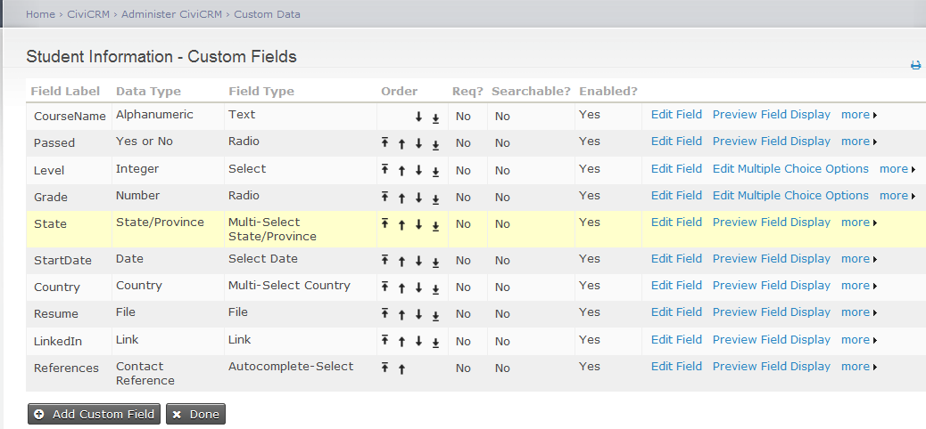

Create CSV file containing the corresponding data as below:
ID,CourseName,Passed,Level,Grade,State,StartDate,Country,Resume,LinkedIn

,Reference
30,Course 1,Yes,A1,B,Texas,08/11/2016,United States,D:\Pics\My CV\Omayma

ElTalawy.doc,https://eg.linkedin.com/in/omayma-saied-2470a664,Adams family

Test Cases.

TEst CASE 1.

Test Case# | Required Inputs | Expected Results |  | Actual Results | Pass/Fail | Bug ID
1 | Validate that Import works for all data types for specific contact type
1 | Open browser and hit http://dmaster.demo.civicrm.org/civicrm/import/custom?reset=1 |  | "Import Multi-value Custom Data" screen appears |  | Pass
2 | Click browse and choose the csv file |  | Csv file is selected |  | Pass
3 | Click on "First row contains column headers" check box |  | " First row contains column headers" is checked |  | Pass
4 | Select "Student Information" from Multi-value custom Data |  | A list of Multi-value Custom Data are available |  | Pass
5 | Select Contact Type: Household |  | Household is selected
6 | Click "Continue" |  | "Match Fields (step 2 of 4)" appears | Strict warning: Declaration of CRM_Custom_Import_Parser::run() should be compatible with CRM_Contact_Import_Parser::run($tableName, &$mapper, $mode = 2, $contactType = 1, $primaryKeyName = '_id', $statusFieldName = '_status', $onDuplicate = 1, $statusID = NULL, $totalRowCount = NULL, $doGeocodeAddress = false, $timeout = 30, $contactSubType = NULL, $dedupeRuleGroupID = NULL) in require_once() (line 35 of /srv/buildkit/build/dmaster/sites/all/modules/civicrm/CRM/Custom/Import/Parser.php). | Fail | CRM-19158
7 | For each field, choose Matching CiviCRM Field from drop down list |  | All Data types defined in Custom fields set are displayed | File Data Type is not displayed in the drop down list | Fail | CRM-19159
8 | Click Continue |  | Preview (step 3 of 4)  Page is displayed
9 | Click "Import Now" |  | Data is imported successfully
10 | Close browser |  | Browser is closed

Table 2 - Use cases and Test Cases

.

Project Tasks/Schedule
Table 4 describes the schedule for the Test Plan of the extension “CiviCRM Multi-value custom data import”.

Task | Artifacts | Projected Completion
Test Plan Completed | Test Plan Version 1.0
Test Environment Prepared | Software
Test Cases Recorded and Executed | Delete Investment, Test Plan Document version 1.0, Test Results Document
Defects submitted and tracked | Unit Test Results Document
Integration test | Test Plan Document Version 1.0
Customer Acceptance Test | Test Plan Document Version 1.0

Table 4 - Project Schedule

Defect Responsibility/Resolution

Possible defects identified through manual testing will be discussed with development team members to verify that the observed behavior constitutes a defect. Defects found will be tried to be resolved. If not possible, they will be delivered with the deliverables as “Known Bugs”. Defect register will be maintained to keep a track of all the defects found in the software.

Exit Criteria

Testing can proceed to the next stage of the process when a sufficient proportion of the current stage has been completed All exit criteria should be satisfied by the end of the project.

8) Goals and Deliverables

Goals and deliverables of the test plan of the “CiviCRM Multi-value custom data import” are as follows –

- Goals:

- To accomplish all tasks described in this test plan.
- To install a measurable, improvable, repeatable, and manageable test process.
- To verify the functionality and content of the current version of the application.
- To reduce the frequency of error associated with manual testing.
- To find and successfully track 100% of defects present along the user path defined in this plan.
- Deliverables:
- Test Planning Stage
- Test Execution and Defect Tracking Stage
- Evaluation and Improvement – this include
          - Test Cycle Evaluation
          - Project Summary / Evaluation

